**DESIGN OF PRECISION RECTIFIER**

**Exp No: 8 Date: 24/03/2022**

**Objective:**

**To design, simulate and verify precision rectifier on LT Spice.**

**Software Required:**

LT SPICE - XVII

**Theory:**

Rectifier circuits are used in the design of power supply circuits. In such applications, the voltage being rectified are usually much greater than the diode voltage drop, rendering the exact value of the diode drop unimportant to the proper operation of the rectifier. Other applications exist, however, where this is not the case. For example, in instrumentation applications, the signal to be rectified can be of very small amplitude, say 0.1 V, making it impossible to employ the conventional rectifier circuits. Also, the need arises for very precise transfer characteristics.

Precision Half-Wave Rectifier- The Super diode There are many applications for precision rectifiers, and most are suitable for use in audio circuits. A half wave precision rectifier is implemented using an op amp, and includes the diode in the feedback loop. This effectively cancels the forward voltage drop of the diode, so very low-level signals can still be rectified with minimal error.

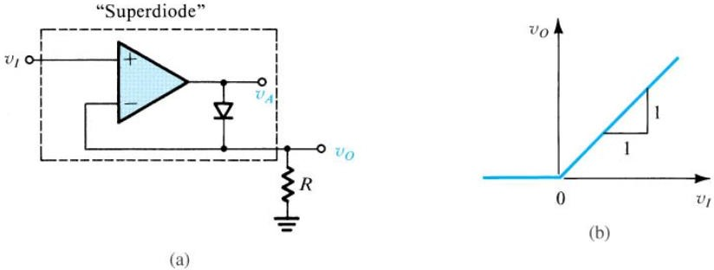

Limitations: -

* The circuit has some serious limitations. The main one is speed. It will not work well with high frequency signals.
* For a low frequency positive input signal, 100% negative feedback is applied when the diode conducts. The forward voltage is effectively removed by the feedback, and the inverting input follows the positive half of the input signal almost perfectly.
* When the input signal becomes negative, the op amp has no feedback at all, so the output pin of the op amp swings negatives as far as it can.
* When the input signal becomes positive again, the op amp's output voltage will take a finite time to swing back to zero, then to forward bias the diode and produce an output. This time is determined by the op amp's slew rate, and even a very fast op amp will be limited to low frequencies.

**Procedure: -**

1. **Open LT Spice and click on new schematic to start the circuit making.**
2. **Components needed are: wires, ground, resistor, op-amp and voltage sources.**
3. **Place them all in the required way as per the requirement of circuit analysis.**
4. **Perform required analysis like transient or ac etc. (simulation commands)**
5. **Run the schematic once the circuit is complete**
6. **Click above the ac input voltage source for the input signal**
7. **Click above the load resistor to obtain the output signal.**
8. **Analyse the input and output obtained from the circuit analysis on LT Spice.**
9. **Save the schematic and continue further analysis if required.**

NON-SATURATION TYPE PRECISION RECTIFIER: -

CIRCUIT:

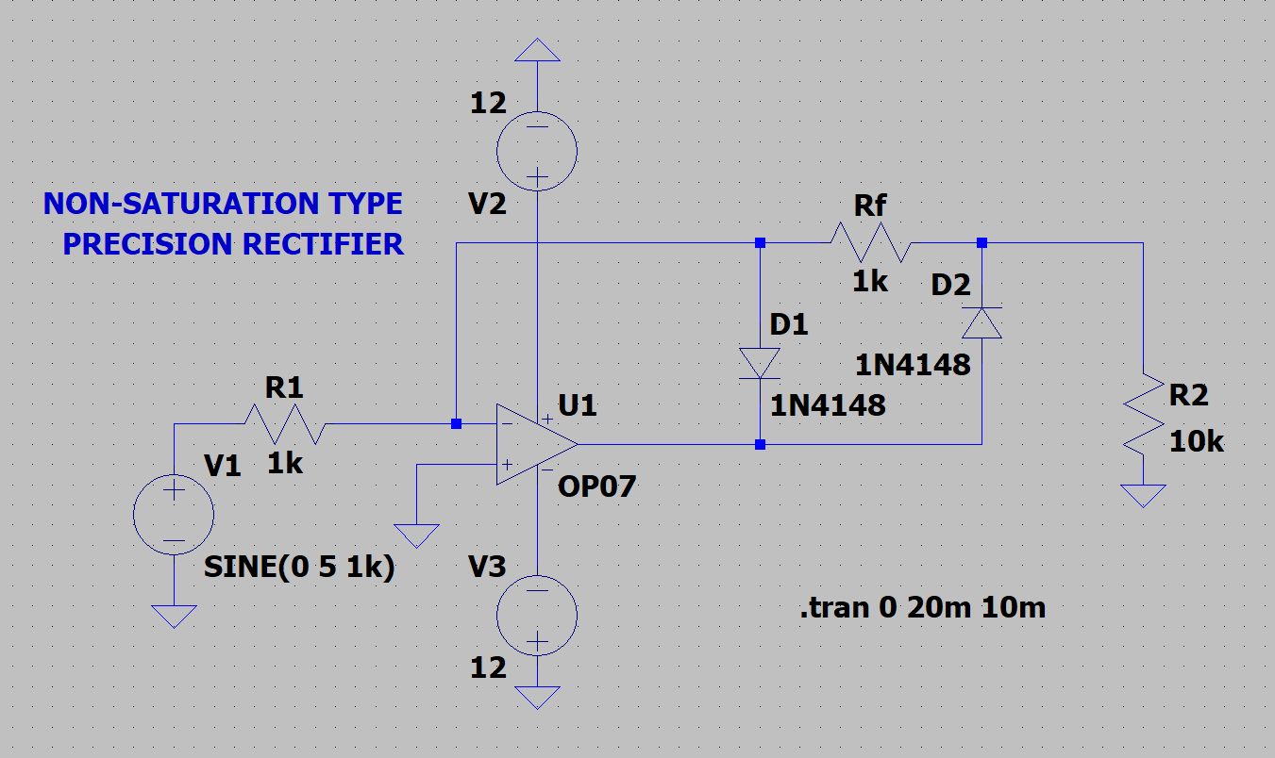

OUTPUT:

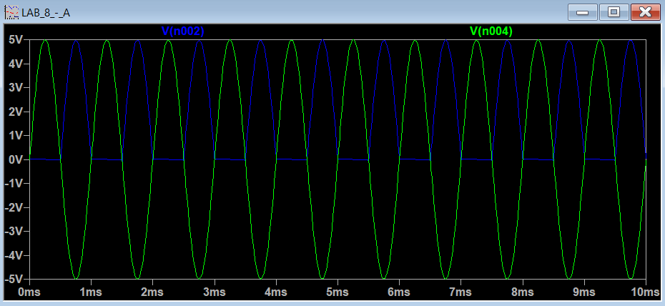

SATURATION TYPE PRECISION RECTIFIER: -

CIRCUIT:

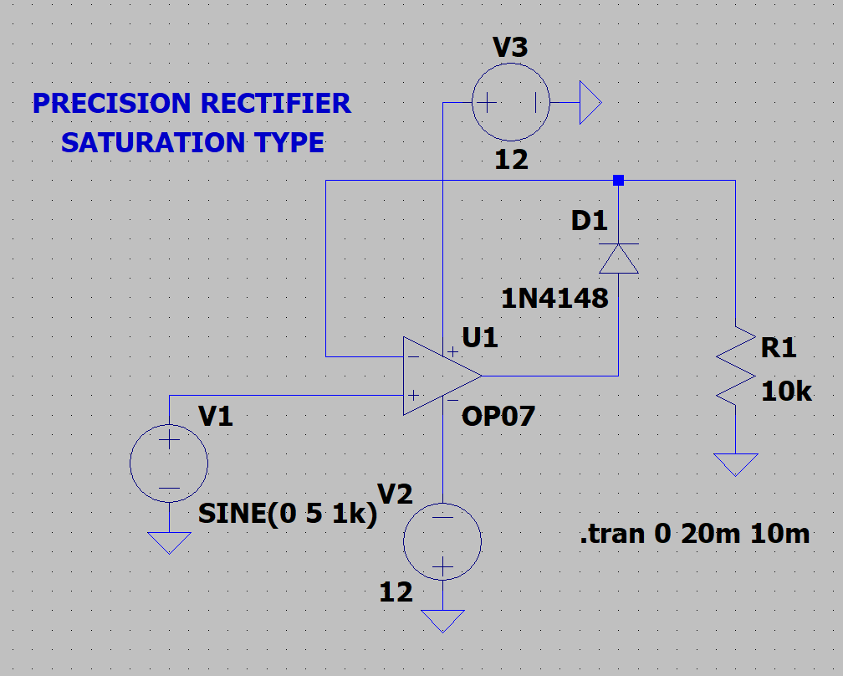

OUTPUT: -

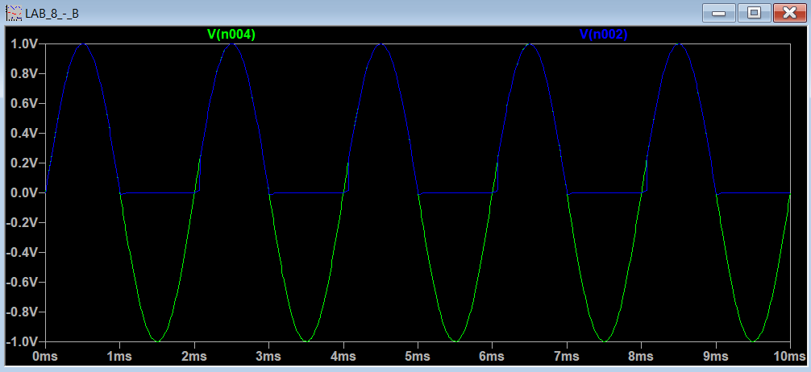

HARDWARE: -

RESULT AND OBSERVATION: -

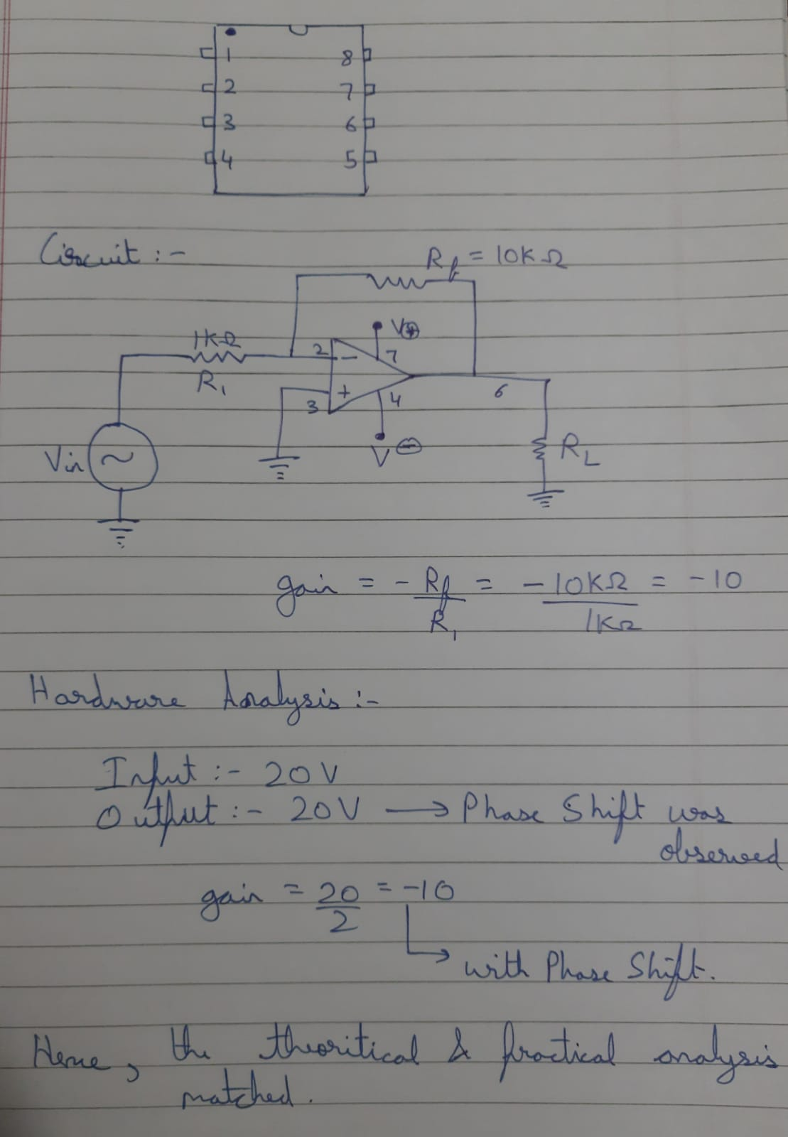

**RESULT: -**

**Thus, HIGH PASS, LOW PASS AND BAND PASS FILTERS designed, tested and verified using LTSPICE.**